Chapter 13, Problem 54.

A transformer is used to match an amplifier with an 8-Ω load as shown in
Fig. 13.118. The Thevenin equivalent of the amplifier is: V_{Th} = 10 V,
Z_{Th} = 128 Ω.

(a) Find the required turns ratio for maximum energy power transfer.

(b) Determine the primary and secondary currents.

(c) Calculate the primary and secondary voltages.

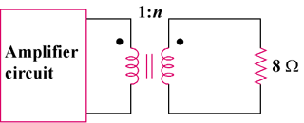

Figure 13.118
For Prob. 13.54.

